**Software Engineering Documentation**

**Project Title:** LMS

**Team Names:** Nina, Dawood, Nick, Anthony, Joshua

**Description:**

LMS Our team will create a Learning Management System, which can store a student's relative information, including their grades, GPA, and what courses they are a part of. The system will also allow the professor to edit student's grades and display relevant information to the professor and will allow admins to have full access to information. This means that an admin can add, remove, and modify any course information, professors or student's information.

The program will allow all reporting purpose, progress in the course, completed semesters years, coming semester year curriculum details, final exam result etc., student’s name, student’s ID, registered courses in the current semester, each exam’s score in one course, GPA calculation in the current semester.

There will be two types of accessing modes, administrator and user. The administrator will be allocated the ability to make changes, updates and see all user's information. The user is either an instructor or a student. Both can view their data, but make no changes to the data, except for the instructor's ability to edit the student's grades.

**Mission Statement:**

The purpose of LMS is to make a program that help professors and administrators organize classes for students. That way the students can keep track of their grades of their courses.

**Mission Objective:**

To maintain (enter, update, and delete) data on students

To maintain (enter, update, and delete) data on professors

To maintain (enter, update, and delete) data on courses

To perform searches on courses

To perform searches on professors

To perform searches on students

To perform searches on grades

To perform searches on GPA

To track the status of grades

To track the status of GPA

To report on grades

To report on GPA

To report on students

To report on professors

**Major User Views:**

Students:

View their grades

View their GPA

Professors:

View student grades

Enter student grades

Maintain student grades

Delete student grades

Administrator:

Enter courses

Maintain courses

Delete courses

Enter professor into courses

Maintain professor from courses

Delete professor from courses

Enter students into courses

Maintain students from courses

Delete student from courses

|  |  |  |  |  |
| --- | --- | --- | --- | --- |
| **Data** | **Access Type** | **Admin** | **Professor** | **Student** |
| All student grades | Maintain |  | X |  |
|  | Query |  | X |  |
|  | Report |  | X |  |
| Single student grades | Maintain |  | X |  |
|  | Query |  | X | X |
|  | Report |  | X |  |
| All Courses | Maintain | X |  |  |
|  | Query | X | X | X |
|  | Report | X |  |  |
| Single Course | Maintain | X |  |  |
|  | Query | X | X | X |
|  | Report | X | X |  |
| All Student | Maintain | X |  |  |
|  | Query | X | X |  |
|  | Report | X |  |  |
| Single Student | Maintain | X |  |  |
|  | Query | X | X | X |
|  | Report | X |  |  |
| All Professors | Maintain | X |  |  |
|  | Query | X | X | X |
|  | Report | X |  |  |
| Single Professor | Maintain | X |  |  |
|  | Query | X | X | X |
|  | Report | X | X |  |
| All Students GPA | Maintain |  |  |  |
|  | Query |  | X |  |
|  | Report |  | X |  |
| Single Students GPA | Maintain |  |  |  |
|  | Query |  | X | X |
|  | Report |  | X |  |

**SPMP:**

<https://drive.google.com/open?id=1Raq-Y6CrqjRZyRDQASG_DGHrvFirg6lM>

**E/R Diagram:**

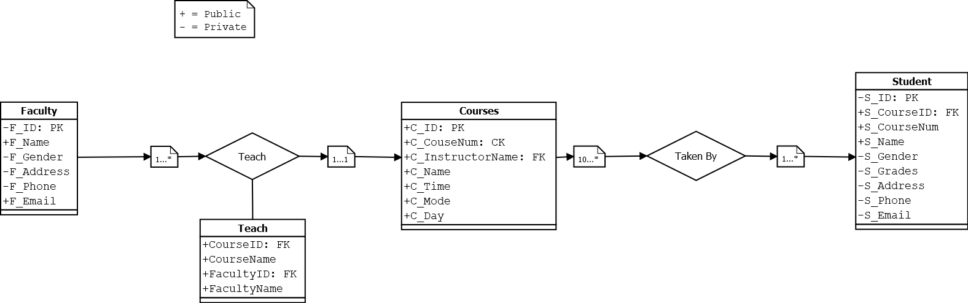

**CRC Cards:**

|  |  |
| --- | --- |
| **Courses** | |
| CourseID  CourseNum  Name  Time  Mode  Day | Students  Instructor |

|  |  |
| --- | --- |
| **Instructor** | |
| Name  InstructorID  Gender  Address  Phone  E-mail | Courses  Students |

|  |  |
| --- | --- |
| **Student** | |
| Name  StudentID  CourseNum  Gender  Address  Grades  Phone  E-mail | Courses  Professor |

**Class Diagram:**

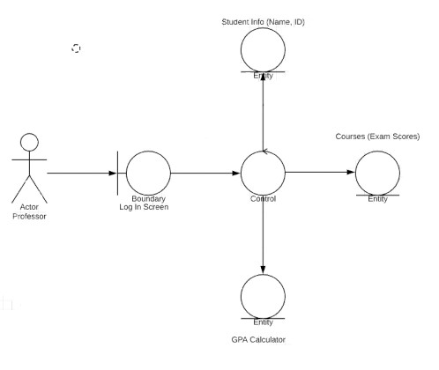

**Collaboration Diagram:**

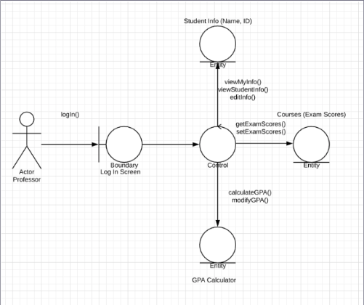

**Sequential Diagram:**

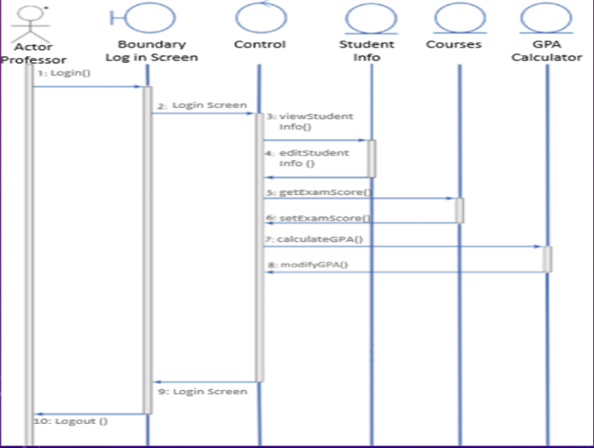

**User Cases:**

Use Case Name: Checking Grades

Actor/User: Student

Steps:

1. Go to the log in page
2. User insert username and password
3. User press button “Login”
4. User is taken to a page under his name
5. User will select “My Grades” link
6. User will choose which class
7. User will be redirected to a new page with a list of his grades.

Use Case Name: Inserting Grades

Actor/User: Instructor

Steps:

1. Go to the log in page
2. User insert username and password
3. User press button “Login”
4. User will be taken to a page under his name
5. User will click “Insert Grades” (taking user taken to a new page)
6. User will choose which class he is going to insert grade (taking user taken to a new page)
7. User will choose which student and drop-down list of assignments will show
8. User will type the grade on empty box belonging to assignment

User Case Name: Checking GPA

Actor/User: Student

Steps:

1. Go to the log in page
2. User insert username and password
3. User press button “login”
4. User will be taken to a page under his name
5. User will select “My Grades” link (takes user to a new page)
6. On this page user will see average grades of his classes and GPA

User Case Name: Checking Enrolled Classes

Actor: Student

Steps:

1. Go to the log in page
2. User insert username and password
3. User press button “login”
4. User will be taken to a page under his name
5. User will select “My Classes” link (takes user to a new page)
6. User is shown all the classes he is enrolled in

User Case Name: Adding professors to courses

Actor: Administrator

Steps:

1. User inputs username
2. User inputs password
3. User clicks “Login” button
4. User clicks on “Professors” tab
5. User inputs professor’s employee ID
6. User inputs professor’s first name
7. User inputs professor’s last name
8. User inputs professor’s password
9. User inputs professor’s position
10. User inputs professor’s department
11. User inputs professor’s office number
12. User inputs professor’s course 1
13. User inputs professor’s course 2
14. User inputs professor’s course 3
15. User inputs professor’s course 4
16. User clicks “Add Professor” button

User Case Name: Adding student to a course

Actor: Administrator

Steps:

1. User inputs username
2. User inputs password
3. User clicks “Login” button
4. User inputs course’s course ID
5. User inputs course’s course number
6. User inputs course’s course name
7. User inputs course’s mode
8. User inputs course’s professor ID
9. User inputs course’s days
10. User inputs course’s class begins
11. User inputs course’s class ends
12. User clicks “Add Course” button

User Case Name: Adding courses

Actor: Administrator

Steps:

1. User inputs username
2. User inputs password
3. User clicks “Login” button
4. User clicks “Students” tab
5. User inputs student’s student ID
6. User inputs student’s first name
7. User inputs student’s last name
8. User inputs student’s password
9. User inputs student’s class level
10. User inputs student’s overall GPA
11. User inputs student’s course 1
12. User inputs student’s course 2
13. User inputs student’s course 3
14. User inputs student’s course 4

User Case Name: Editing Professor Information or Courses

Actor: Administrator

Steps:

1. User inputs username
2. User inputs password
3. User clicks “Login” button
4. User clicks on “Professors” tab
5. User clicks on professor list drop down box
6. User will see a list of professors
7. User clicks on the professor he wants to modify
8. User will see all the information from professor and his courses
9. User changes the information he needs to change
10. User clicks “Modify Professor” button

User Case Name: Editing Professor’s Information or Courses

Actor: Administrator

Steps:

1. User inputs username
2. User inputs password
3. User clicks “Login” button
4. User clicks on courses list drop down box
5. User will see a list of courses
6. User clicks on the course he wants to modify
7. User will see all the information of the courses
8. User changes the information he needs to change
9. User clicks “Modify Professor” button

User Case Name: Editing Course’s Information

Actor: Administrator

Steps:

1. User inputs username
2. User inputs password
3. User clicks “Login” button
4. User clicks on “Professors” tab
5. User clicks on professor list drop down box
6. User will see a list of professors
7. User clicks on the professor he wants to modify
8. User will see all the information from professor and courses
9. User changes the information he needs to change
10. User clicks “Modify Course” button

User Case Name: Editing Student’s Information or Courses

Actor: Administrator

Steps:

1. User inputs username
2. User inputs password
3. User clicks “Login” button
4. User clicks on “Students” tab
5. User clicks on student list drop down box
6. User will see a list of students
7. User clicks on the student he wants to modify
8. User will see all the information from student and his courses
9. User changes the information he needs to change
10. User clicks “Modify Student” button

User Case Name: Deleting Professor’s Information or Courses

Actor: Administrator

Steps:

1. User inputs username
2. User inputs password
3. User clicks “Login” button
4. User clicks on courses list drop down box
5. User will see a list of courses
6. User clicks on the course he wants to delete
7. User will see all the information of the courses
8. User clicks “Delete Professor” button

User Case Name: Deleting Course’s Information

Actor: Administrator

Steps:

1. User inputs username
2. User inputs password
3. User clicks “Login” button
4. User clicks on “Professors” tab
5. User clicks on professor list drop down box
6. User will see a list of professors
7. User clicks on the professor he wants to modify
8. User will see all the information from professor and courses
9. User clicks “Delete Course” button

User Case Name: Deleting Student’s Information or Courses

Actor: Administrator

Steps:

1. User inputs username
2. User inputs password
3. User clicks “Login” button
4. User clicks on “Students” tab
5. User clicks on student list drop down box
6. User will see a list of students
7. User clicks on the student he wants to modify
8. User will see all the information from student and his courses
9. User changes the information he needs to change
10. User clicks “Modify Student” button